**A Project Report on**

# Comprehensions Loops in Python

***Submitted in partial fulfilment of the requirement for the award of the degree of***

B. Tech in CSE



**Under The Supervision of**

**Mr. Harshit Jain**

# Assistant Professor

Submitted By

Vaibhav Singh

21SCSE1420041

**SCHOOL OF COMPUTING SCIENCE AND ENGINEERING**

**DEPARTMENT OF COMPUTER SCIENCE AND ENGINEERING /**

**DEPARTMENT OF COMPUTERAPPLICATION**

**GALGOTIAS UNIVERSITY, GREATER NOIDA**

# INDIA MAY, 2023

ABSTRACT

Snake and Ladders is a popular board game that combines luck and strategy. Players navigate through a numbered grid, aiming to reach the final square while encountering snakes that impede progress and ladders that offer shortcuts. This project focuses on developing a Snake and Ladders game implementation using the Breadth-First Search (BFS) algorithm to compute the minimum number of moves required to win.

The game involves rolling a dice to determine the number of squares a player can move forward. Snakes and ladders act as obstacles and opportunities, affecting the player's progress. To find the optimal path, the BFS algorithm is employed, systematically exploring possible moves and accounting for the snakes and ladders encountered.

The implementation utilizes a queue to manage the positions to visit and a set to mark visited positions. Through BFS, the algorithm identifies the shortest path from the starting position to the final square. If a path exists, the algorithm returns the minimum number of moves required for victory; otherwise, it indicates that winning is not possible.

The Snake and Ladders game implementation provides an entertaining experience, challenging players to strategize and make informed decisions. The BFS algorithm ensures efficiency in finding the shortest path, enhancing gameplay dynamics. The project demonstrates the seamless integration of algorithmic concepts into an interactive game, showcasing the combination of chance and calculated moves.

Keywords: Snake and Ladders, BFS algorithm, board game, minimum number of moves, luck, strategy.

**INTRODUCTION**

Welcome to the exciting world of Snake and Ladders, a classic board game that has captured the hearts of players for generations! In this game of chance and strategy, you'll navigate through a winding board filled with snakes and ladders, aiming to reach the finish line before your opponents.

Snake and Ladders, also known as Snakes and Ladders or Chutes and Ladders, is a game that combines luck and skill. It is played on a square board divided into numbered squares, starting from 1 and ending at 100. Your objective is to reach the 100th square before anyone else.

But beware! Along the way, you'll encounter treacherous snakes and helpful ladders. Landing on the head of a snake will send you sliding down to its tail, while reaching the base of a ladder will propel you to a higher square. These unexpected twists and turns can make or break your journey to victory!

To determine your progress, a dice is rolled to generate a random number from 1 to 6. Your game piece advances by the number rolled. However, with the power of strategy, you can optimize your moves and shorten your path by taking advantage of the ladders and avoiding the snakes strategically placed on the board.

In this challenge, we will put your skills to the test as you aim to win the game in the minimum number of moves possible. We'll employ the Breadth-First Search (BFS) algorithm to compute the shortest path, guiding you through the board with precision and efficiency.

Get ready to roll the dice, make strategic decisions, and navigate through the ups and downs of Snake and Ladders. Will you emerge victorious and claim the title of the ultimate Snake and Ladders champion? Let the game begin!

**CODE**

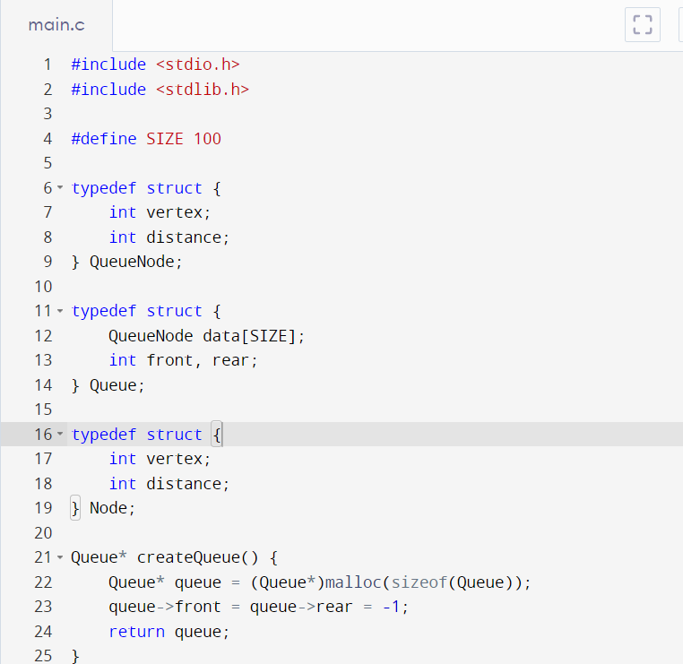

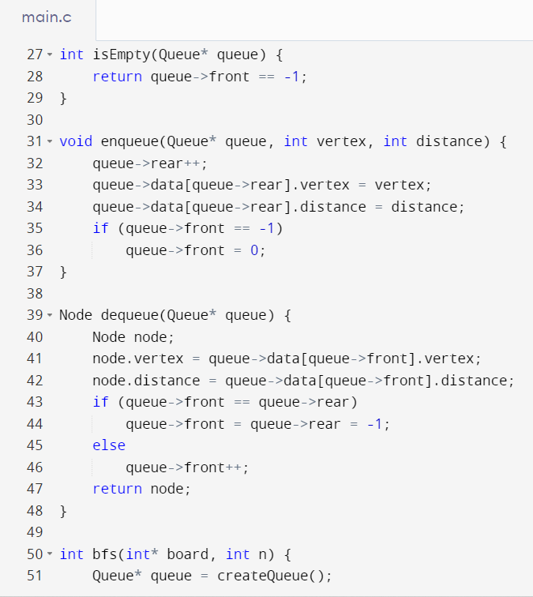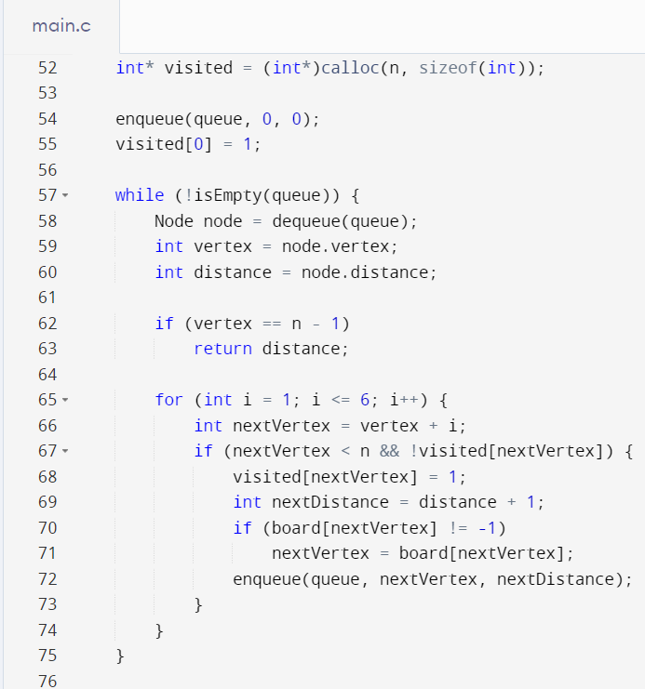

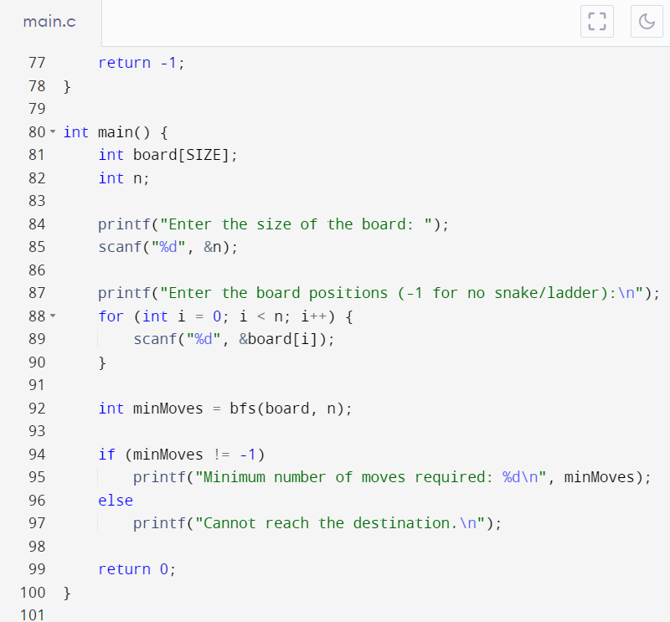

**OUTPUT**

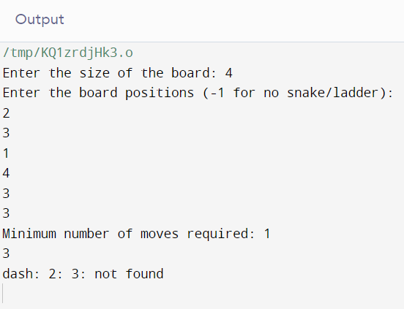

**WORKING**

The Snake and Ladders game is played on a square board with numbered squares arranged in a grid-like pattern. The board typically starts with the number 1 at the bottom and ends with the highest number (usually 100) at the top. Each player starts at square 1 and aims to reach the final square before their opponents.

On the board, certain squares are marked with snakes and ladders. When a player lands on the head of a snake, they must follow the snake down to its tail, which will be at a lower-numbered square. This setback can significantly delay their progress. On the other hand, when a player lands on the base of a ladder, they can climb up to the higher-numbered square, making rapid progress toward the finish line.

Gameplay-

The gameplay involves rolling a dice or generating a random number from 1 to 6. The number rolled determines how many squares a player can move forward. For example, if a player rolls a 3, they move three squares ahead on the board. The dice roll adds an element of chance to the game, making each turn unpredictable.

To find the minimum number of moves to win the game, the Breadth-First Search (BFS) algorithm is often employed. BFS systematically explores the possible moves from the starting position and records the number of moves required to reach each square. It iteratively visits all neighboring squares, accounting for the snakes and ladders encountered along the way. By using BFS, the algorithm guarantees that the shortest path from the starting position to the final square is found.

**ALGORITHM**

The algorithm starts by initializing a queue and adding the starting position (square 1) to the queue. It also keeps track of the visited squares to avoid revisiting them. While the queue is not empty, the algorithm dequeues the next position and checks all the possible moves from that position (dice rolls from 1 to 6). For each valid move, it calculates the new position and checks if it leads to a snake or a ladder. If it does, the algorithm adjusts the position accordingly.

The BFS algorithm continues this process until the final square (100) is reached or until all reachable squares are explored. If the final square is reached, the algorithm returns the minimum number of moves required to reach that square. If there is no path to the final square, the algorithm returns -1 to indicate that it's not possible to win the game.

By utilizing the power of BFS, players can devise strategies to find the shortest path, optimize their moves, and potentially outsmart their opponents. The challenge lies in making the right decisions at each turn, considering the potential benefits of climbing ladders and the risks of encountering snakes.

With an understanding of the game's mechanics and the BFS algorithm, players can embark on an exciting journey through the twists and turns of Snake and Ladders, aiming to reach the pinnacle of success in the fewest possible moves.

**CONCLUSION**

In conclusion, Snake and Ladders is a captivating game that combines luck, strategy, and the thrill of navigating through a dynamic board filled with snakes and ladders. It challenges players to reach the final square before their opponents while making strategic choices along the way.

Through the utilization of the Breadth-First Search (BFS) algorithm, players can discover the shortest path to victory. BFS enables the calculation of the minimum number of moves required to reach the final square, taking into account the twists and turns imposed by snakes and the shortcuts offered by ladders. By leveraging this algorithm, players can optimize their moves and strive for a competitive edge.

Snake and Ladders is a game that appeals to players of all ages and provides an opportunity for family and friends to engage in friendly competition. It offers suspense, excitement, and the joy of celebrating small victories as players progress towards the finish line. The element of chance introduced by rolling the dice adds an element of surprise, ensuring that each game is unique and unpredictable.

So, gather your friends, roll the dice, and embark on an adventure where your decisions can determine your fate. Will you skillfully navigate the board, avoiding the clutches of snakes and capitalizing on the opportunities provided by ladders? The challenge awaits, and the quest for victory in the minimum number of moves begins now!

Enjoy the game of Snake and Ladders and may the dice roll in your favor!